**CLFMA Classroom Series in association NCDEX on Price Risk Management on 21st August, 28th August 2021 & 4th September, 2021**

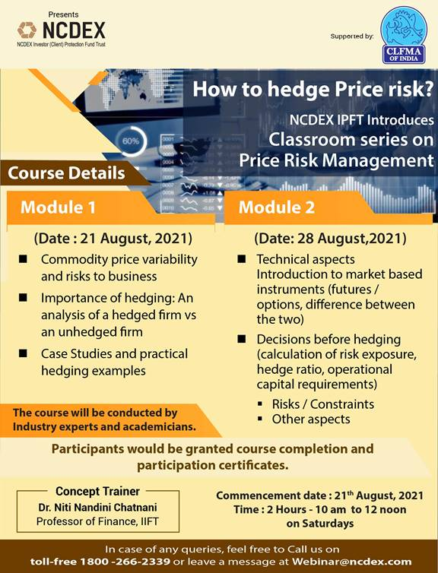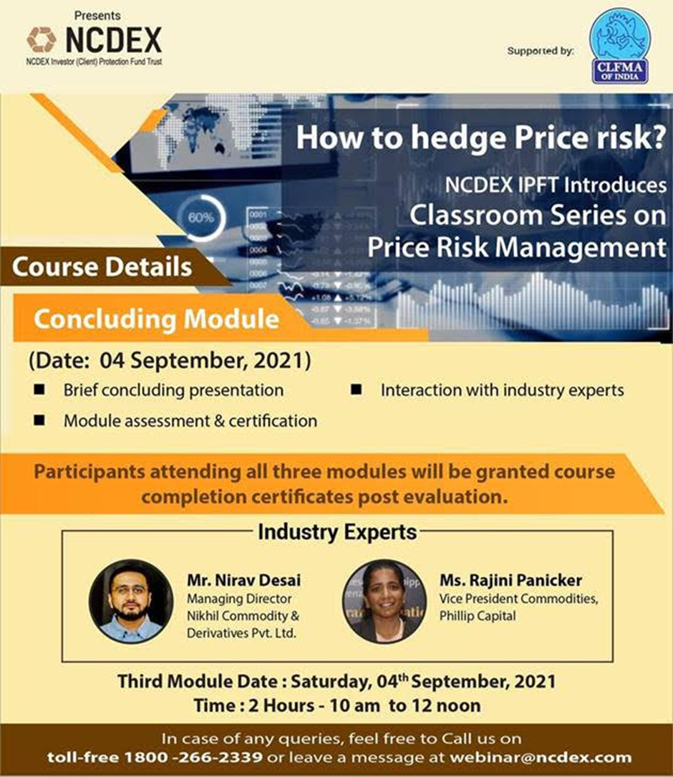

CLFMA along with NCDEX organized Classroom Series on Price Risk Management on 21st August, 28th August 2021 & 4th September, 2021 with active participation of CLFMA Members. Mr. Neeraj kumar Srivastava extended a vote of thanks during the last Classroom Series on Price Risk Management on 4th September, 2021. It was a successful event and almost 30 Members attended the same.